Signing up for Google Docs
- Log into Blackboard (fcps.blackboard.com) On your home page, select FCPS Google Apps Resources
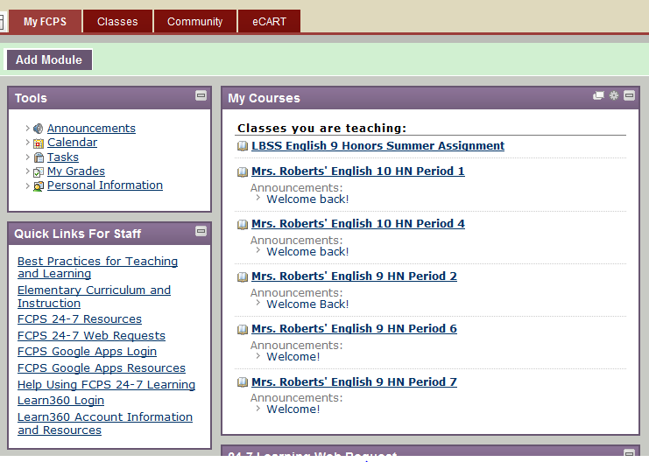
- On the next screen, select “Activate your account” if this is your first time using Google Docs. You can also see that you can access your account and reset your password from this same location. Follow the directions for activating your account.
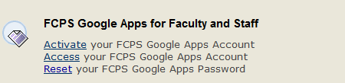
Signing in and resetting passwords
- You can access Google Docs by going directly to docs.google.com and sign in using userID@fcpsschools.net
- Or you can access it by signing in to Blackboard, going to the first class in your course menu and choosing the “Google Apps” button.
Creating
- To create a new document, spreadsheet, PowerPoint, or quiz (form), simply click on the “create” button and select the type of document you want to make. Once you are in your new document. Click on the name (automatically set to “Untitled Document”) and type in the file name you’d like to use. Documents are saved automatically as you work.
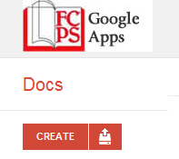
Uploading and Downloading
- You can upload any type of document to Google Docs. All Microsoft Office files (Word, PowerPoint, etc.) can be uploaded and edited on Google Docs.
  - To upload, go to the home page of your Google Docs (known as your Google Drive). Click the red import button next to “create” and select your file.
- You can also download any document created on Google Docs to edit on Microsoft Office.
  - To download, open the document, and then choose: file/download as…
Organizing and Sharing
- If you’re going to save multiple documents for the same project, you may want to start a collection
  - Click, “Create” then select “collection”.
  - Click and drag any documents that are part of this collection into the folder. Anyone you’ve shared the collection with will automatically be able to see any new document you add.
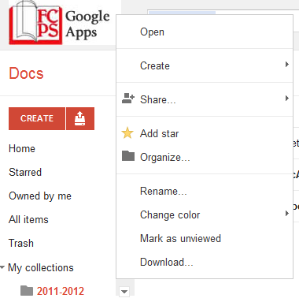
- If you want to share your work with another teacher or a student, you need to know the person’s first and last name or userID
  - Collections: hover over the name of the collection on the left-hand side of the screen and click on the down arrow that appears. Then select “share” and type in the name(s) of those you want to share with.

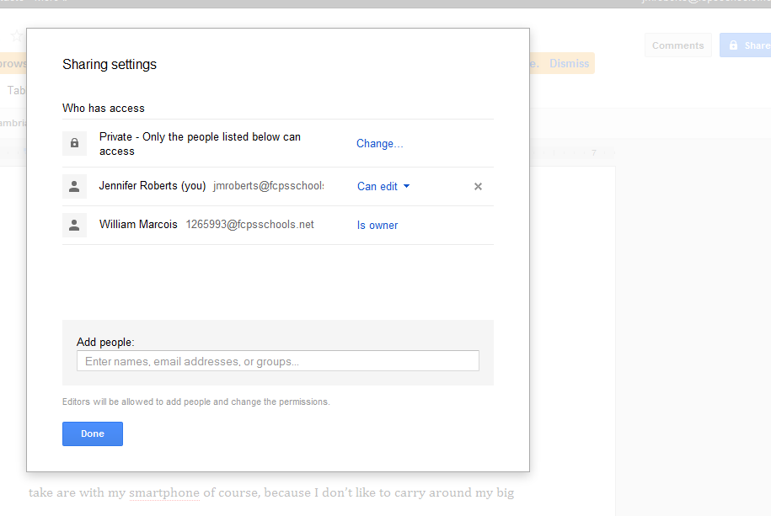
  - Individual Documents: Open the document and click the large blue “Share” button in the upper-right-hand part of the screen. Then type in names (or ID numbers) of collaborators.

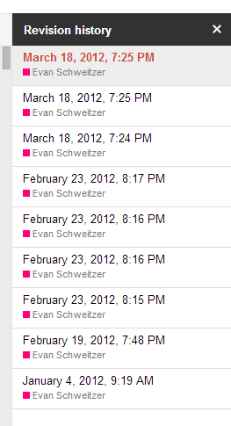
Commenting and Collaborating
- You can choose to allow your collaborators to edit, comment, or simply view your document.
- Note: If you are assigning students to a group for a project, you can monitor their individual work and collaborative contributions using Google. Set up a Collection and share it with the members of the assigned group, changing their settings to allow each to edit documents saved in the collection.
- By viewing revision history, you can see exactly what each student contributed to each document. Simply go to file/see revision history when you have the document open. Google will color code the document to show each contributor in a different color. It will also show you the date and time of each revision. This can also be helpful in seeing a single student’s revision history on an essay.
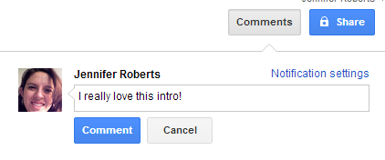
- The collaborative features are helpful for CLTs to conduct virtual meetings and create collaborative documents. You and another teacher can work on a document at the same time. You can also add notes to different parts of a document for your team members to view at a later date by highlighting a portion of the document and selecting “comments.”

